Press Release, 9 December 2013

Practices of urban governance and public space in Beirut, Cairo and Tehran
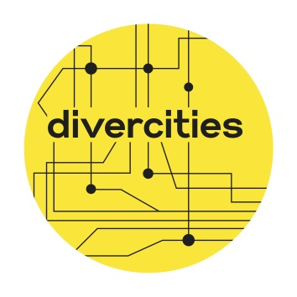
How are contested spaces governed on a local level? How are experiences of urban governance perceived and practiced by different social agents in view of the ambivalence of public space in diverse societies? These are some of the questions at the core of a series of events organised by the Orient-Institut Beirut (OIB) and the Goethe Institut Lebanon in various locations across Beirut from 12 to 14 December 2013 under the title “Divercities: contested space and urban identities in Beirut, Cairo and Tehran”.

Divercities aims to look at urban governance, its agents, agendas and options, through contested space and conflicting urban concepts, identity claims and social environments. Situated at the core of social and political fractions, contested spaces reveal insights into the dynamics of diverse societies and urban identities. The focus will be on the three cities of Beirut, Cairo and Tehran, each highlighting different types of fragmentations, political, social and cultural.

In three multidisciplinary panels – Claims and Agency, Between Public and Private, Open Air Spaces of Gathering: Norms and Practices – participants from Lebanon, Egypt, Iran, Germany and beyond will discuss power dynamics over contested spaces and propose alternative readings of public space.

Highlights include a panel discussion on “What does Beirut’s Urban Future Look Like” with Bilal Hamad (Mayor of Beirut), Amira Solh (Solidere), Vladimir Kurumilian (urban activist), Omar Abi Azar (Zoukak Theatre Company), and moderated by Rami G. Khouri. The collaborative Dictaphone Group will perform a range of projects based on findings and stories produced through multidisciplinary research on space and oral history, including Bus Cemetery and This Sea is Mine. The improvisational theatre organisation Laban: Live Lactic Culture will explore the topic of contested space together with the audience through its Masar Theatre.

The events will take place in an old warehouse in Karantina, at the Orient-Institut Beirut (OIB) in Zokak el-Blat, at Zico House in Spears and at Mansion in Zokak el-Blat. Registration will take place on each day. For more information, visit the blog http://divercities.hypotheses.org.

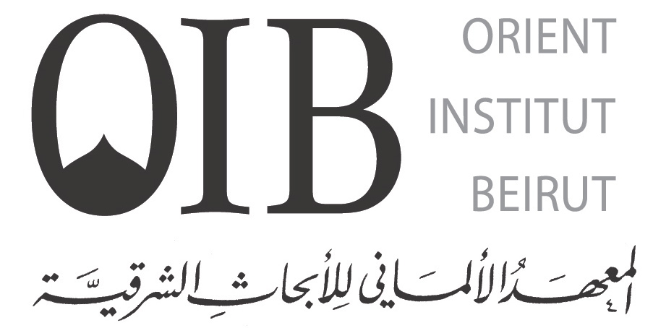
Contact:
Dr. Nadia von Maltzahn
Orient-Institut Beirut
Rue Hussein Beyhum, 44 Zokak el-Blat
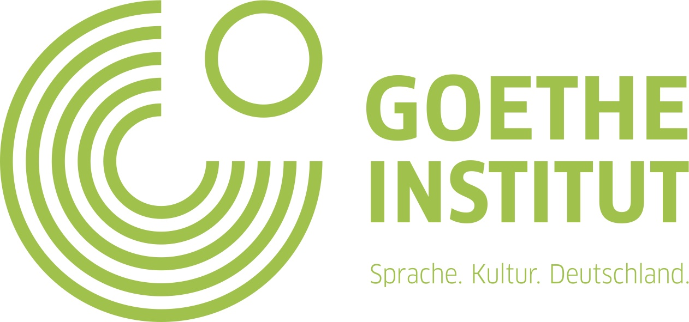
POB 11-2988 Beirut, Lebanon
Tel: +961 (0)1 359 182; Mob: +961 76 50 46 26
Fax: + 961 (0)1 359 176
Email: maltzahn@orient-institut.org
www.orient-institut.org and www.goethe.de/libanon

